MasterCard What it really does an independent trusted third party to process to process payment between merchant’s bank and credit card issuer bank. escrow

Our prosposal to build MPEMS to motivated by the following:

- Growing number of credit/debit card users and smartphone users

- Spenders getting more sophisticated
  - Due to the competitiveness in credit card consumer market. More banks are introducing all types of promotion. Spenders are taking advantages of these promotions by using different cards for different spendings

  - Spender have strategies to spend more to earn more

- Lack of value added services provided by existing payment network
  - VISA, AMEX or diners do not have such service in the market
- (and finally, this is also)An opportunity to enhance customer’s experience with MasterCard
  - This will help MasterCard to achieve their long term goal of expanding their market share

- Expense Tracker
  - Consolidated view of all their mastercard transaction
  - Analyze their spending by period and by category

- Budget Assistant
  - Individual card or over all budget by week and month
  - Get sms notification when budget exceeds
  - Set spending target for individual card by month
- Reward Point Programmes
  - earn reward points and use reward points to exchange for vouchers
- Exclusive MasterCard Deals
  - Subscribe to mastercard exclusive deals
- System Administration
  - Maintain the system
    - Create deals
    - Create vouchers

Finally, these value added services could certainly
The Responsive Web Design is the practice to use fluid layouts and media queries to create designs able to adapt according to the user’s screen resolution. It allows to eliminate the need to create different designs (read templates) for each device (that in these days means desktop, netbook, tablet and mobile). - http://www.maurizioconventi.com/2012/02/08/responsive-web-design-with-twitter-bootstrap/ example : http://spigotdesign.com/

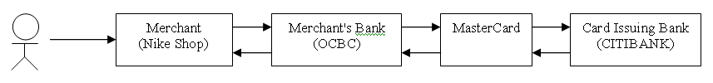
MASTERCARD
CENTRAL
DATABASE
MPEMS
(Grail)
MPEMS
DATABASE
(MySQL)
ETL
Trigger
SMS
WebService
Smartphone
Tablet
Desktop
MPEMS
USER
Responsive Web HTML
Telco
SMS

